

**Enriched Academy User Manual**

**USER-** There are 2 types of users.

1. Pro User**-:** Pro user has access to all the services provided by Enriched Academy includes Workbook, Tools, and Videos.
2. Free User-: Free user has access to limited services provided by Enriched Academy

Include only 4 videos.

**User Registration Sources-** There are 8 type of sources from which user can login into enriched academy.

1. **Website-** This is the user registration page of Enriched Academy paid users who has access code. User will be able to register for particular client with the given access code.

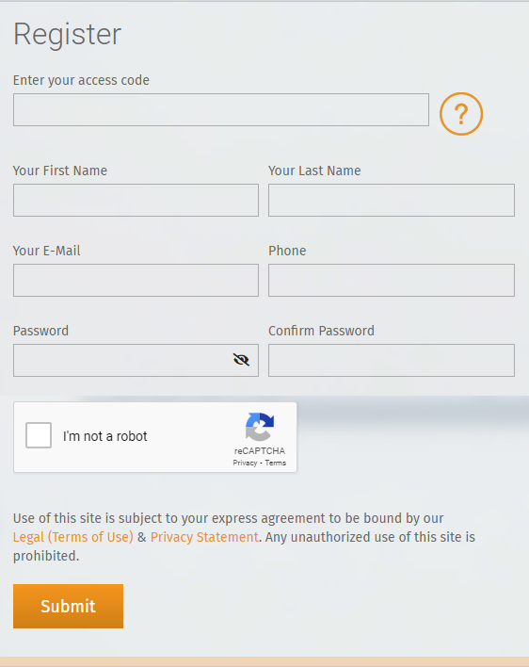

1. **Mobile App-** In mobile app u can only use calculator. There are 2 type of users **Pro-User and Free User**
2. **Pro-User-** This is Mobile APP for Pro user registration with access code. User will be able to register for particular client with the given access code.



1. **Free User-** This is free user Register User Screen for Mobile APP. Free user do not have complete access of the services offered by Enriched Academy.



1. **Developer API-**In this API you can easily track the user activity which at its most basic acts as a door or window into a software program, allowing other programs to interact with it without the need for a developer to share its entire code. From API you can easily track his Completion certificate, Get user, Register user, Video API, Get user API, Total view API, Current Status API, Delete User API, Total Registered API, Video views API, Most popular Video API, Rating and feedback API this all work can be done by developer.
2. **Marketing API-** In the marketing APIit's defined as “code that makes data and/or functionality from one website available for use in other applications.”
3. **Cake PHP API-**Cake PHP is a **Single Sign-on (SSO)** that enables users to securely authenticate with multiple applications and websites by using just one set of credentials.

**Moodle API-** It is Learning Management System through which user can register into enriched academy by Clicking on Connect with Enriched Academy button. Moodle provide facility so that user can connect with any of the website. User need to install plug-in in to Moodle by doing that the link is created through which user get register and login into Enriched Academy and again when user come for second time he just need to click that button and can login into the Enriched Academy account.

1. **Brightspace API-** Currently we are working on this APIs.
2. **Canvas API-** Currently we are working on this APIs

**Covid-19 User Registration-** This was the functionality added through the time of Covid-19 by Enriched Academy to provide free financial education to Canadian people.

**User Dashboard-** On User Dashboard user can watch course video and then complete the quiz for each course or they can go into Debt Crusher tool, Net worth Calculator, Annual saving calculator and Workbook and Tools.

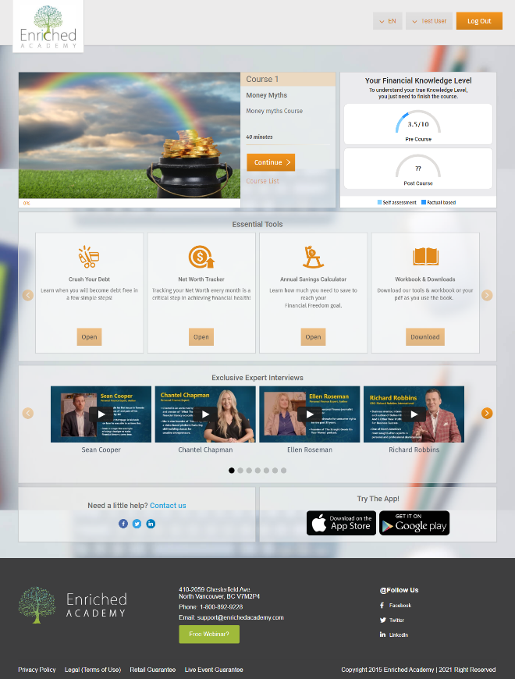

**COURSES-** A direction or route taken or to be taken. the path, route, or channel along which anything moves: the course of a stream. advance or progression in a particular direction; forward or onward movement. A program of instruction, as in a college or university but in the **Enriched Academy** there are 2 types of courses we are giving **Mandatory Course** and **Bonus Course**.

1. **Mandatory Course-** Once user will complete the Mandatory course they have to give the Survey for Enriched Academy and now user can download there certificate. After certificate they have to complete the Post Quiz to show if user have increased their financial knowledge level or not.
2. **Bonus Course-** Bonus course is not a compulsory course but If you want you can watch the course.

**Essentials Tools-** Enriched Academy provides you the tools that help you to build your wealth in a good way. There are 2 types of tools in it **Workbook** and **Calculators and tools.**

1. **Workbook-** In this you can learn about workbook, FAQs, Phone bill Reduction Script, Investing Terms Glossary.

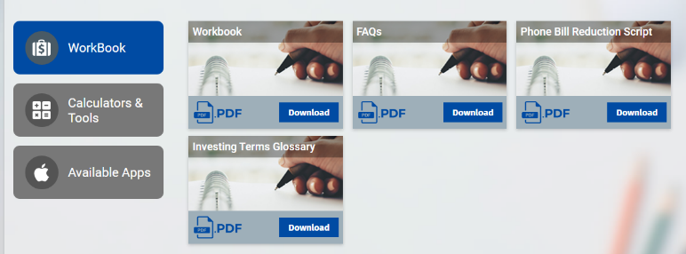

1. **Calculators and tools-** Net Worth Tracker, Financial Freedom Calculator, Budget Worksheet, RRSP & Tax Savings Calculator, Real Estate Purchase Analyzer, Real Estate Rental Application, Real Estate Lease Agreement, Real Estate Rental Inspection Checklist, Real Estate ROI Analyzer, Compound Interest Analyzer.

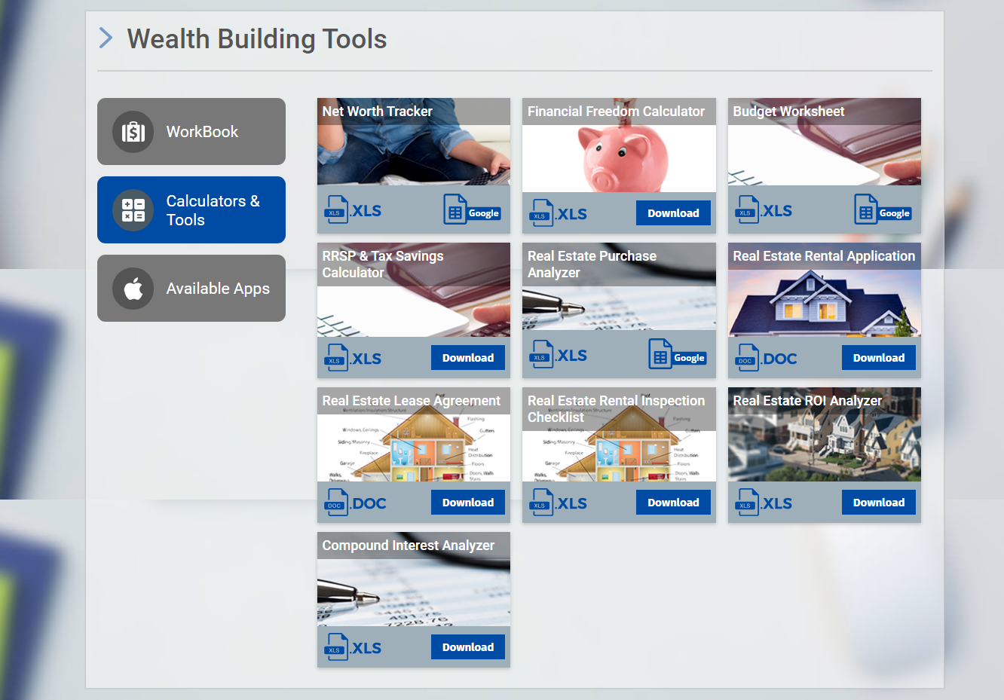

**Awareness Score-** Awareness score is a combined score of Pre Quiz and Post Quiz. This is also known as Financial Knowledge Score.

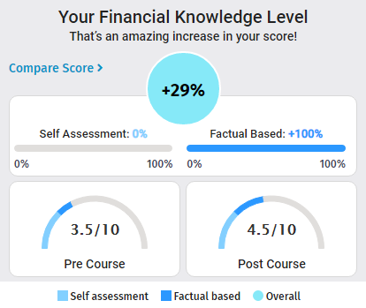

**Expert Interview:** On user dashboard there are expert interview videos user can watch that and see what experts are saying for Enriched Academy.

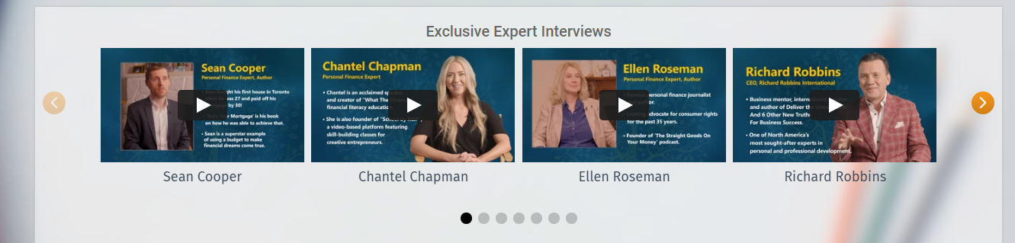

**Dashboard Banner-** If you click on this banner this banner will directly take you to Enriched Academy Team and they will analyse your financial situation. But in some vertical you will not able to get this banner.



**(This all Calculators and tools comes under the Essential Tools)**

**Crush Your Debt-** In this section if user has debt/loan they can add their debt here and check when they are going to be debt free and it can also guide user about how they can crusher their debt. It shows users about snow ball method to get debt free as soon as possible.

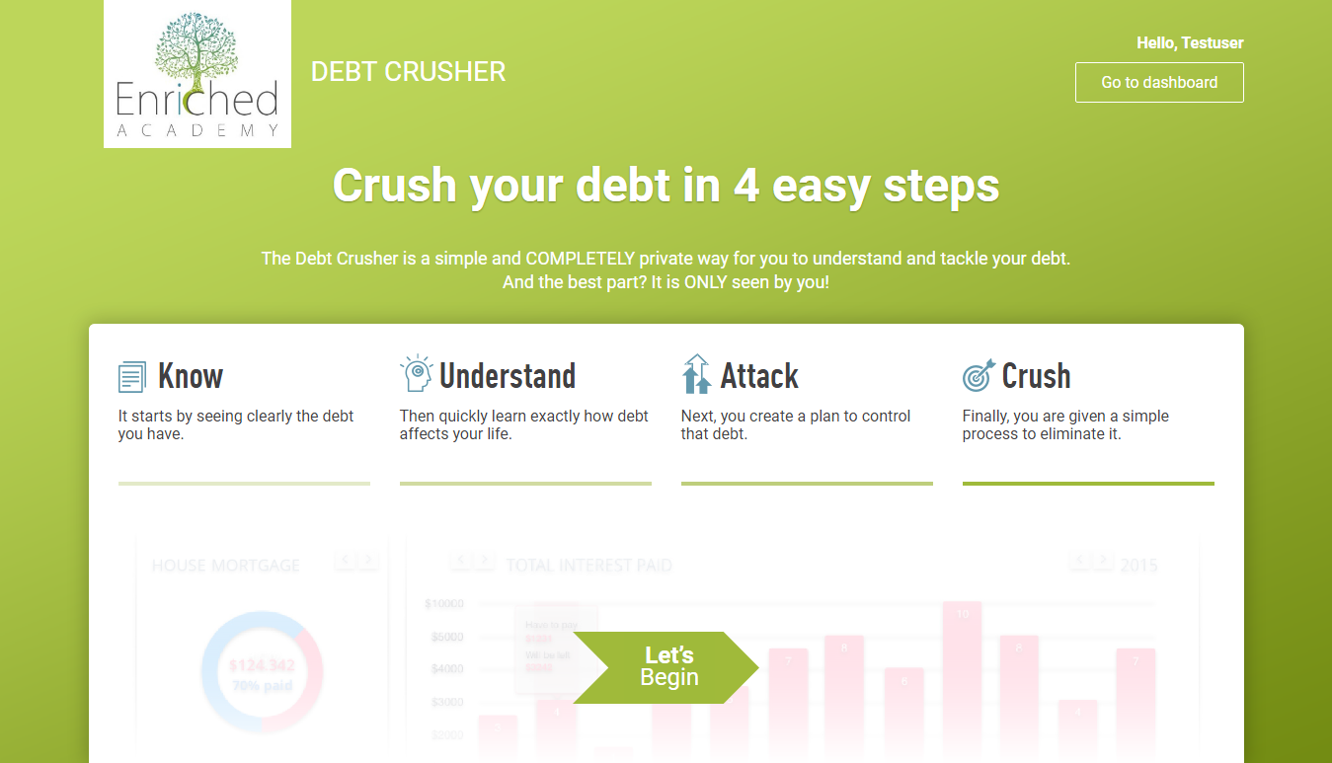

**Networth Calculator-** In this user can add their Assets and Liabilities and can calculate their net worth. Currently user can only add the data in current month. In the footer there is Talk to Our team button user can click on it and connect with Enriched Academy team. This is our Net worth screen.

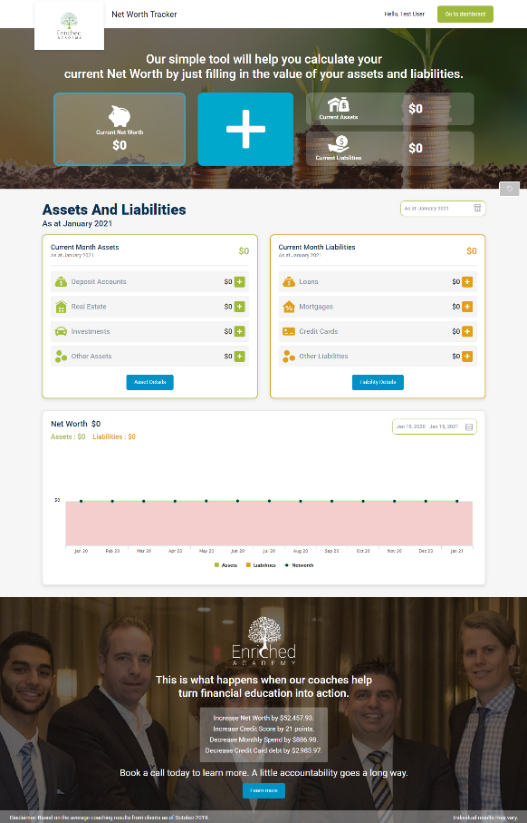

**Financial Freedom Calculator-** With the help of this calculator user can plan their retirement and can save the money what they want after retirement and also user can interact with financial expert to save more. This is the screen of financial freedom calculator.

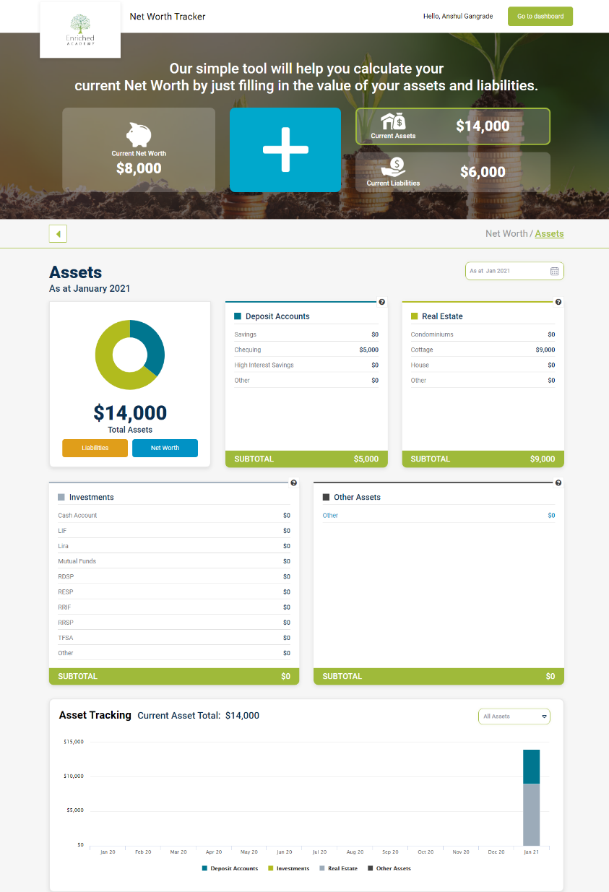

**Your Credit Score-** There is a link in Enriched Academy website through which we can go to the Transunion where user can login and get there credit score.

The Name of the section is your Consumer Disclosure.

**Workbooks And Downloads-** In Workbook we get the fill in the blank and expert view on the course which we watch into the Enriched Academy.

And we can downloads all the Tool from this section for example Net worth sheet, Financial Freedom Sheet, Budget Sheet and many more. It help user to plan their net worth, Budget and also have some inspection checklist of home rents.

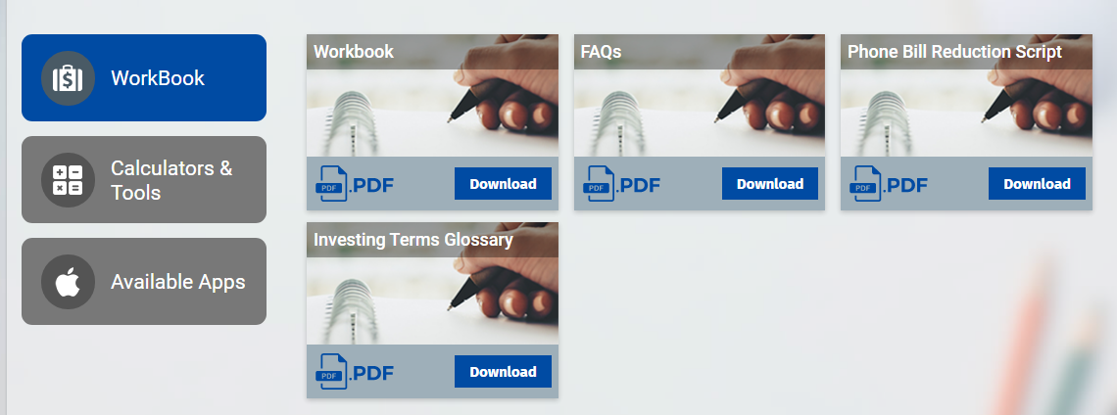

**Financial Health Score-** For old users these section appears and through which we can analyze how much financial knowledge they have regarding their financial status.

